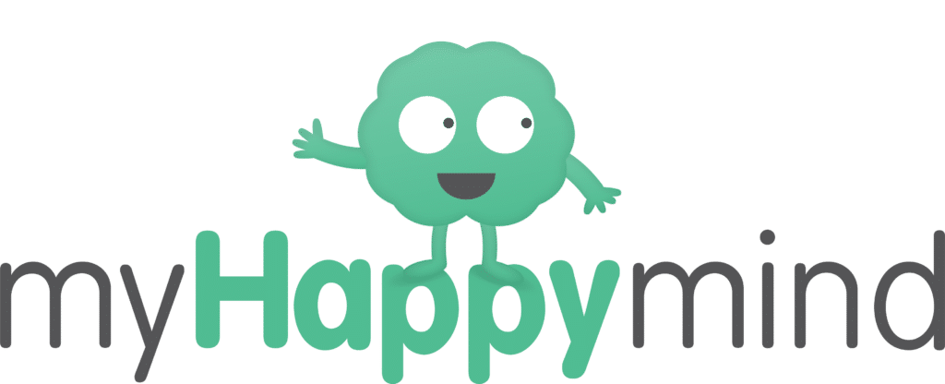

**Year 5 Homework - Friday 6th June 2025**

This term we have launched a programme of work called ‘My Happy Mind’. This looks in detail at how our brain works and how we can boost positive mental health and wellbeing.

For homework this week we would like you to think about what activities you could do or strategies you have used to help with the following scenarios you may deal with…

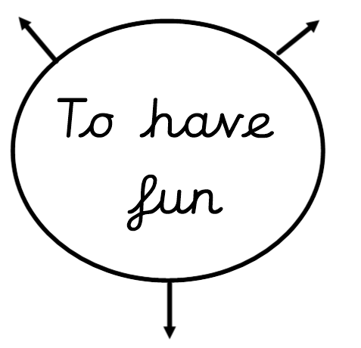

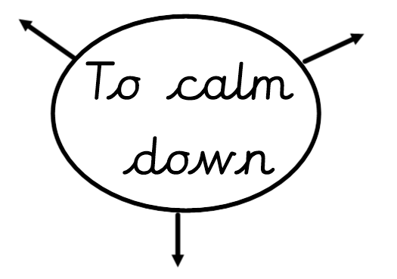

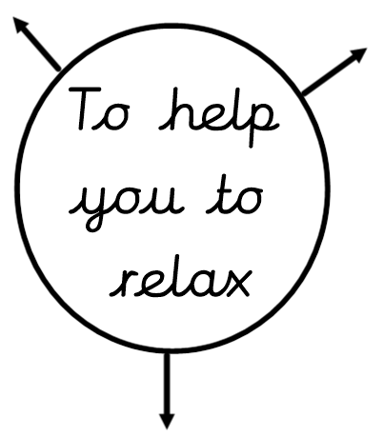

**Homework due in – Friday 13th June 2025**

